**3**

**STRUCTURE OF THE NERVOUS SYSTEM**

TABLE OF CONTENTS

To access the resource listed, click on the hot linked title or press **CTRL + click**

To return to the Table of Contents, click on click on **▲** [**Return to Table of Contents**](#CHOPN_TOC)

To return to a section of the Lecture Guide, click on **►** [**Return to Lecture Guide**](#LectureGuide)

[**TEACHING OBJECTIVES**](#TeachingObjectives)

[**KEY TERMS**](#KeyTerms)

LECTURE GUIDE

* [Basic Features of the Nervous System](#LG_I_BasicFeatures) (p. 64)
* [Development of the Nervous System](#LG_IIR_DevelopmentNervousSystem) (p. 65)
* [Structure and Function of the Central Nervous System](#LG_II_CentralNervousSystem) (p. 67)
* [Structure and Function of the Peripheral Nervous System](#LG_III_PeripheralNervousSystem) (p. 70)

FULL CHAPTER RESOURCES

* [Lecture Launchers](#LL_List) (p. 73)
* [Classroom Activities](#Activities_List) (p. 78)
* [Assignments](#Assignments_List) (p. 82)
* [Handouts](#Handouts_OPN) (p. 84)
* [PowerPoint Presentations](#PP_Presentations) (p. 105)
* [Accessing All Resources](#AccessingAllResources) (p. 106)

TEACHING OBJECTIVES

After the completion of this chapter, the student should be able to:

1. Apply anatomical terms to the nervous system.
2. Differentiate the locations of the three layers of the meninges.
3. Describe the locations and functions of CSF within the ventricular system.
4. Summarize the process of human brain development from ectoderm plate, to neural tube, to three interconnected chambers.
5. Explain how prenatal development contributes to the development of complex human brains.
6. Provide examples of how genetic change, personal experience, and neurogenesis can influence postnatal brain development.
7. Identify the structures and functions of the forebrain, including the telencephalon and diencephalon.
8. Identify the location and functions of the structures of the mesencephalon.
9. Contrast the locations and functions of the structures of the metencephalon and myelencephalon.
10. Describe the structure and functions of the spinal cord.
11. Identify the functions of the cranial nerves.
12. Differentiate between the functions of the afferent and efferent axons of the spinal nerves.
13. Compare the functions and locations of the sympathetic and parasympathetic divisions of the autonomic nervous system.

▲ [Return to Chapter 3: Table of Contents](#CHOPN_TOC)

KEY TERMS

cerebrospinal fluid (text p. 58)

neuroaxis (text p. 59)

anterior (text p. 59)

posterior (text p. 59)

rostral (text p. 59)

caudal (text p. 59)

dorsal (text p. 59)

ventral (text p. 59)

lateral (text p. 59)

medial (text p. 59)

ipsilateral (text p. 59)

contralateral (text p. 59)

cross section (text p. 59)

frontal section (text p. 59)

horizontal section (text p. 59)

sagittal section (text p. 61)

midsagittal plane (text p. 61)

meninges (meninx) (text p. 61)

dura mater (text p. 61)

arachnoid membrane (text p. 61)

pia mater (text p. 61)

subarachnoid space (text p. 61)

ventricle (text p. 61)

lateral ventricle (text p. 61)

third ventricle (text p. 61)

cerebral aqueduct (text p. 61)

fourth ventricle (text p. 61)

choroid plexus (text p. 61)

arachnoid granulation (text p. 62)

superior sagittal sinus (text p. 62)

obstructive hydrocephalus (text p. 63)

neural tube (text p. 64)

cerebral cortex (text p. 65)

progenitor cells (text p. 66)

ventricular zone (text p. 66)

subventricular zone (SVZ) (text p. 66)

symmetrical division (text p. 66)

asymmetrical division (text p. 66)

radial glia (text p. 66)

apoptosis (text p. 66)

forebrain (text p. 70)

cerebral hemisphere (text p. 70)

subcortical region (text p. 70)

sulcus (text p. 70)

fissure (text p. 70)

gyrus (text p. 70)

frontal lobe (text p. 71)

parietal lobe (text p. 71)

temporal lobe (text p. 71)

occipital lobe (text p. 72)

primary visual (or striate) cortex (text p. 72)

calcarine fissure (text p. 72)

primary auditory cortex (text p. 72)

lateral fissure (text p. 72)

primary somatosensory cortex (text p. 72)

central sulcus (text p. 72)

insular cortex (text p. 72)

sensory association cortex (text p. 72)

primary motor cortex (text p. 74))

motor association cortex (text p. 74)

prefrontal cortex (text p. 74)

corpus callosum (text p. 75)

neocortex (text p. 75)

limbic cortex (text p. 75)

cingulate gyrus (text p. 75)

limbic system (text p. 75)

hippocampus (text p. 75)

amygdala (text p. 75)

fornix (text p. 75)

mammillary bodies (text p. 75)

basal ganglia (text p. 76)

nucleus (text p. 76)

diencephalon (text p. 76)

thalamus (text p. 76)

projection fiber (text p. 77)

lateral geniculate nucleus (text p. 77)

medial geniculate nucleus (text p. 77)

ventrolateral nucleus (text p. 77)

hypothalamus (text p. 77)

optic chiasm (text p. 77)

anterior pituitary gland (text p. 78)

neurosecretory cell (text p. 78)

posterior pituitary gland (text p. 78)

midbrain (text p. 78)

mesencephalon (text p. 78)

tectum (text p. 78)

superior colliculi (text p. 78)

inferior colliculi (text p. 78)

brain stem (text p. 78)

tegmentum (text p. 79)

reticular formation (text p. 79)

periaqueductal gray matter (text p. 79)

red nucleus (text p. 79)

substantia nigra (text p. 79)

hindbrain (text p. 79)

cerebellum (text p. 79)

cerebellar cortex (text p. 79)

deep cerebellar nuclei (text p. 79)

cerebellar peduncle (text p. 79)

pons (text p. 79)

medulla oblongata (text p. 80)

spinal cord (text p. 80)

spinal root (text p. 81)

cauda equina (text p. 81)

caudal block (text p. 81)

dorsal root (text p. 82)

ventral root (text p. 82)

cranial nerve (text p. 82)

vagus nerve (text p. 82)

olfactory bulb (text p. 83)

spinal nerve (text p. 83)

afferent axon (text p. 84)

dorsal root ganglion (text p. 84)

efferent axon (text p. 84)

somatic nervous system (text p. 84)

autonomic nervous system (text p. 84)

sympathetic division (text p. 84)

sympathetic ganglia (text p. 84)

sympathetic ganglion chain (text p. 85)

preganglionic neuron (text p. 85)

postganglionic neuron (text p. 86)

adrenal medulla (text p. 86)

parasympathetic division (text p. 86)

▲ [Return to Chapter 3: Table of Contents](#CHOPN_TOC)

LECTURE GUIDE

I. Basic Features of the Nervous System (Text p. 58)

▲ [Return to Chapter 3: Table of Contents](#CHOPN_TOC)

Lecture Launchers

* [3.1 Concept Maps](#LL_ConceptMaps)
* [3.2 Learning Biological Terminology](#LL_BiologicalTerminology)
* [3.4 Telling Stories](#LL_TellingStories)
* [3.7 Describe the Contents of the Brain in Terms of a Recipe](#LL_ContentsofBrain)
* [3.9 Chronic Traumatic Encephalopathy (CTE)](#LL_CTE)

Activities

* [Physical Metaphors to Create Mental Models](#Activity_PhysicalMetaphors)

Handouts

* [3.1 Concept Maps of the Nervous System](#Handout_ConceptMap)
* [3.6 Learning Medical Terms](#Handout_LearningMedTerms)
* [3.7 Learning Medical Terms: Basic Greek and Latin](#Handout_LearningMedTermsGreek)

A. Basic Features of the Nervous System (Figure, text p. 58)

1. Central nervous system (CNS): brain and spinal cord (Figure 3.1, text p. 59)

2. Peripheral nervous system (PNS): nerves and peripheral ganglia

3. Brain encased in skull and floating in cerebrospinal fluid (CSF)

4. Blood supply essential

a. Brain gets 20% of blood flow

b. Brain cannot store energy

c. Needs oxygen to extract energy

d. Disruption of blood flow results in unconsciousness in 6s

B. Anatomical terms (Figure 3.2, text p. 60; Figure 3.3, text, p. 61)

1. Neuraxis—a line drawn through the length of the CNS

2. Anterior/Posterior

3. Rostral/Caudal

4. Dorsal/Ventral

5. Latera/Medial

6. Ipsilateral/Contralateral

7. Planes

a. Transverse (also known as cross section or frontal section)

b. Horizontal

c. Sagittal

C. Meninges

1. Central nervous system

a. Dura mater: tough, outer layer

b. Arachnoid membrane

1. Sub-arachnoid space filled with CSF

c. Pia mater: closely attached to brain and spinal cord

2. Peripheral nervous system

a. Dura mater and pia mater fuse

b. No arachnoid membrane

c. No CSF

D. The Ventricular System and Production of CSF (Figure 3.4, text p. 62)

1. Brain ventricles: hollow chambers

a. Lateral ventricles: largest

b. Third ventricle

i. Divides brain into symmetrical halves

ii. Massa intermedia—bridge of neural tissue through the third ventricle

c. Cerebral aqueduct

d. Fourth ventricle

2. Cerebrospinal fluid (CSF)

a. Produced by choroid plexus

b. About 125 ml with a half-life of three hours

c. Continuously produced and removed

d. Protects brain from hitting skull during normal head movements

e. Arachnoid granulations

1. Superior sagittal sinus

2. Reabsorbs CSF into the blood stream

f. Obstructive hydrocephalus (Figure 3.5, text p. 63)

1. CSF can’t drain

2. If pressure is not relieved, brain damage occurs

II. DEVELOPMENT OF THE NERVOUS SYSTEM (Text p. 64)

▲ [Return to Chapter 3: Table of Contents](#CHOPN_TOC)

Lecture Launchers

* [3.1 Concept Maps](#LL_ConceptMaps)
* [3.10 Metaphors for Apoptosis and Development of the Complex Brain](#LL_ApoptosisBrainDev)

Handouts

* [3.1 Concept Maps of the Nervous System](#Handout_ConceptMap)

A. Overview of Brain Development (Critical Concepts, text p. 66)

1. Neural Plate (Figure 3.6, text p. 64)

a. Begins 18 days post-conception

b. Nervous system is derived from ectoderm

c. Neural plate forms first

d. Neural folds are formed on the plate

e. The neural folds fuse to become the neural tube (which becomes brain and spinal cord)

2. Neural tube (Figure 3.7, text p. 65)

a. Neural tube closed by 28th day of development

b. Rostral end of tube develops three chambers

c. Chambers become the ventricles

d. Surrounding tissue becomes three major parts of the brain (Table 3.1, text p. 65)

i. Forebrain (the telencephalon)

ii. Midbrain (the diencephalon or mesencephalon)

iii. Hindbrain (the metencephalon and myelencephalon)

*B. Prenatal Brain Development*

1. Cerebral cortex (Figure 3.8, text p. 67)

a. 3 mm thick

b. Surrounds the cerebral hemispheres

c. Corrected for body size, the cortex is larger in humans than any other species

d. Cortex develops from the inside out

2. Progenitor cells

a. Located just inside the neural tube in the ventricular zone

b. Stem cells that give rise to the brain

c. Phases of development

i. Symmetrical division

a. Each division results in two progenitor cells

b. First phase of development

c. Some migrate to form the subventricular zone

ii. Asymmetrical division

a. Each division results in one progenitor cell and one brain cell

3. Radial glia

a. First brain cells produced by asymmetrical division

b. Extend fibers radially outward

c. Feet maintain connection to pia mater

d. Neurons migrate along fibers

i. Early cells migrate in about one day

ii. Last neurons take about two weeks

4. Apoptosis (Video, text p. 67; Figure 3.9, text p. 67)

a. Chemical signal causes progenitor cells to die

b. Neurons that form synaptic connections survive

c. System is designed to overproduce neurons and then prune those that are not being used

5. Development of Complex Brains

a. Gene duplication

i. Allows one copy to perform important functions

ii. Frees other copy for “experimentation”

iii. Size differences between species due to simple processes

a. Three to four extra symmetrical divisions would account for large brain

b. Human period of symmetrical and asymmetrical division lasts a little longer in humans

c. A few mutations in the genes that control the timing of development could underlie delay

b. Larger brains require convolutions allowing more neurons

i. Role of the Subventricular Zone

a. Thicker in species with convoluted brains

b. Inner and outer layers

c. In human, progenitor cells migrate to inner subventricular zone

d. Undergo asymmetrical division

e. Increases neurons in the cortex, forcing it to bend and fold

*C. Postnatal Brain Development*

1. Development of the brain continues for at least 20 years

2. Influences on development

a. Genetics

b. Experience

i. Example: ability for stereopsis (depth perception) requires visual input

3. Neural rewiring may occur in the adult

4. Neurogenesis

a. Occurs in the adult brain

b. Demonstrated in olfactory bulb and hippocampus (Figure 3.11, text p. 69)

IIi. structure and function of the central nervous system (Text p. 69)

▲ [Return to Chapter 3: Table of Contents](#CHOPN_TOC)

Lecture Launchers

* [3.1 Concept Maps](#LL_ConceptMaps)
* [3.2 Learning Biological Terminology](#LL_BiologicalTerminology)
* [3.4 “Handy” Model of the Brain](#LL_HandyModel)
* [3.6 3-D Diagrams and Models](#LL_3DDiagramsandModels)

Activities

* [3.1 Bring Real Nervous Systems to Class](#Activity_BringReal)
* [3.3 Diagrams of the Nervous System](#Activity_DiagramsNervousSystem)
* [3.4 The Brain Game](#Activity_BrainGame)
* [3.5 Brain Dissection](#Activity_BrainDissection)
* [3.6 Using Movies to Teach Neuroscience](#Activity_Movies)
* [3.7 Learning by Coloring](#Activity_Coloring)

Assignments

* [3.1 Vocabulary Crossword Puzzle](#Assignment_Crossword)
* [3.2 Fill in the Nervous System](#Assignment_FillIn)

Handouts

* [3.1 Concept Maps of the Nervous System](#Handout_ConceptMap)
* [3.2 Vocabulary Crossword Puzzle](#Handout_Crossword)
* [3.3 A “Handy” Model of the Human Brain](#Handout_HandyModel)
* [3.4 Diagrams of the Nervous System](#Handout_DiagramNervousSystem)
* [3.5 Organizational Chart: Structure of the Nervous System](#Handout_StructureNervousSystem)
* [3.6 Learning Medical Terms](#Handout_LearningMedTerms)
* [3.7 Learning Medical Terms: Basic Greek and Latin](#Handout_LearningMedTermsGreek)

A. The Forebrain (Figure 3.12, text p. 71)

1. Telencephalon

a. Cerebral Cortex (Figure 3.13, text p. 71)

i. Convoluted

a. Sulci are small grooves

b. Fissures are large grooves

c. Gyri are bulges between the sulci and fissures

ii. Dimensions

a. 2360 cm2

b. 3 mm thick

iii. Composed of glia, cell bodies, dendrites, and axons

iv. Cell bodies predominate giving grayish color (gray matter)

v. Axons (with myelin) are below the cortex

vi. Lobes (Figure 3.14, text p. 72)

a. Frontal

b. Parietal

c. Temporal

d. Occipital

vii. Sensory regions (Figure 3.15, text p. 74)

a. Primary visual cortex (or striate cortex)

1. Back of brain along calcarine fissure

b. Primary auditory cortex

1. Lower surface of the lateral fissure

c. Primary somatosensory cortex

1. Just caudal to the central sulcus

2. Base of somatosensory cortex and insular cortex receive taste information

3. Other than olfaction and gustation, sensory information goes to the contralateral primary sensory cortex

viii. Sensory association cortex

a. Analyze information from primary sensory cortex

b. Location of perception

c. Location of sensory memory

d. Damage results in somatosensation deficits

ix. Association areas

a. Responsible for perceiving, learning, remembering, planning, acting

x. Motor regions (Figure 3.16, text p. 74)

a. Primary motor cortex

1. Just in front of primary somatosensory cortex

b. Connections between brain and muscles are contralateral

xi. Motor association cortex

a. Controls primary motor cortex, controlling behavior

xii. Prefrontal cortex

a. Important for formulating plans and strategies

xiii. Lateralization

a. Hemispheres do not perform identical function

b. Left

1. Analysis

2. Recognizes serial events

a. Verbal activities

b. Talking

c. Comprehension of speech

d. Reading

e. Writing

c. Right

1. Synthesis—puts isolated elements together

a. Drawing

b. Reading maps

c. Constructing complex objects out of smaller elements

d. Corpus callosum (Figure 3.17, text p. 75)

1. Axons connecting left and right hemispheres

2. Connections can be seen using diffusor tensor imaging

xiv. Midsagittal structures (Figure 3.18, text p. 76)

a. Neocortex

b. Limbic cortex

1. Cingulate gyrus

c. Corpus callosum

b. Limbic system (Figure 3.19, text p. 76)

i. Structures

a. Limbic cortex

b. Hippocampus

c. Amygdala

d. Fornix

e. Mammillary bodies

ii. Functions

a. Emotion

b. Learning and memory

c. Basal ganglia (Figure 3.20, text p. 77)

i. Subcortical nuclei involved in control of movement

ii. Major parts

a. Caudate

b. Putamen

c. Globus pallidus

2. Diencephalon (Figure 3.20, text p. 77)

a. Thalamus

i. Two lobes connected by the massa intermedia

a. Absent in many people

ii. Projection fibers

a. Axon from cell bodies in one region that synapse onto neurons in other brain regions

iii. Divisions

a. Lateral geniculate nucleus

1. Relays visual information to primary visual cortex

b. Medial geniculate nucleus

1. Relays auditory information to primary auditory cortex

c. Ventrolateral nucleus

1. Relays information from the cerebellum to primary motor cortex

b. Hypothalamus (Figure 3.21, text p. 77)

i. Functions

a. Regulates autonomic nervous system

b. Regulates endocrine system

c. Four F’s: feeding, fighting, fleeing, fornicating

ii. Controls the pituitary gland (Figure 3.22, text p. 78)

a. Hypothalamic hormones are released by neurosecretory cells

b. Anterior pituitary

1. Blood vessels connect hypothalamus to pituitary

2. “Master gland”

c. Posterior pituitary

1. Hormones produced in hypothalamus

2. Released by the posterior pituitary

3. Hormones

a. Oxytocin

b. Vasopressin

C. The Midbrain (Mesencephalon; Figure 3.23, text p. 79)

1. Tectum

a. “Roof”

b. Inferior colliculi (audition)

c. Superior colliculi (vision)

d. Colliculi appear as bumps on the brain stem

2. Tegmentum

a. “Covering”

b. Reticular formation (arousal, attention, reflexes)

c. Periaqueductal gray matter (sequences of movement)

d. Red nucleus (motor information from cerebral cortex and cerebellum to spinal cord)

e. Substantia nigra (projects to basal ganglia)

D. The Hindbrain (Figure 3.24, text p. 80)

1. Metencephalon

a. Cerebellum

1. Standing, walking, coordinated movements

2. Cerebellar cortex

3. Deep cerebellar nuclei

4. Attached to pons by cerebellar peduncles

b. Pons

1. Contains part of the reticular formation

2. Sleep and arousal

3. Relay from cortex to cerebellum

2. Myelencephalon

a. Medulla oblongata

1. Regulates cardiovascular system, respiration, and skeletal muscle

E. The Spinal Cord (Figures 3.25 and 3.26, text p. 81)

1. Protected by bony vertebrae

2. Divisions of spinal column

a. Cervical

b. Thoracic

c. Lumbar

d. Sacral

e. Coccygeal

2. Cauda equina

a. Composed of spinal roots

b. Caudal block results from drug blocking axon conduction in cauda equina

3. Dorsal and ventral roots

IV. structure and function of The Peripheral Nervous System (Text p. 82)

▲ [Return to Chapter 3: Table of Contents](#CHOPN_TOC)

**Lecture Launchers**

* [3.1 Concept Maps](#LL_ConceptMaps)
* [3.7 Disorders of the Peripheral Nervous System](#LL_312)
* [3.8 Shingles](#LL_313)

**Assignments**

* [3.1 Vocabulary Crossword Puzzle](#Assignment_Crossword)
* [3.2 Fill in the Nervous System](#Assignment_FillInNS)

**Handouts**

* [3.1 Concept Maps of the Nervous System](#Handout_ConceptMap)
* [3.2 Vocabulary Crossword Puzzle](#HandoutDescript_Crossword)
* [3.5 Organizational Chart: Structure of the Nervous System](#HandoutDescript_OrgChart)

A. Cranial nerves (Figure 3.27, text p. 83)

1. 12 pairs

2. Sensory and motor functions of the head and neck

3. Vagus (10th nerve): functions of the organs in the thoracic and abdominal cavities

4. Receives somatosensory information, with olfaction being an exception

B. Spinal nerves (Figure 3.28, text p. 84)

1. Afferent

a. Incoming

b. Somatosensory

c. Dorsal root ganglia contains soma of sensory neurons

d. Unipolar

2. Efferent

a. Away from

b. Muscles and glands

c. Ventral root

C. The Autonomic Nervous System (Figure 3.29, text p. 85)

1. Part of the PNS, along with the somatic nervous system

2. Regulates smooth muscle, cardiac muscle, and glands

3. Divisions (Table 3.2, text p. 86)

a. Sympathetic division

i. Involved with expenditure of energy

ii. Cell bodies of sympathetic motor neurons in thoracic and lumbar parts of the spinal cord (thoracolumbar system)

a. Send fibers out of ventral root of spinal nerve (preganglionic)

b. Fibers enter sympathetic ganglia

c. Neurons in ganglia send axons to target organs (postganglionic)

iii. Regulates adrenal medulla

iv. Preganglionic axons secrete acetylcholine, postganglionic axons secrete epinephrine

b. Parasympathetic division

i. Involved in increasing body’s stored energy

ii. Cell bodies of motor neurons in some cranial nerves and sacral region of the spinal cord (craniosacral system)

a. Send fibers out of ventral root of spinal nerve

b. Preganglionic neurons—long axons

c. Fibers enter parasympathetic ganglia near target

d. Neurons in ganglia send axons to target organs

e. Postganglionic neurons—short axons

▲ [Return to Chapter 3: Table of Contents](#CHOPN_TOC)

FULL CHAPTER RESOURCES

Lecture Launchers

* [3.1 Concept Maps](#LL_ConceptMaps)
* [3.2 Learning Biological Terminology](#LL_BiologicalTerminology)
* [3.3 Telling Stories](#LL_TellingStories)
* [3.4 “Handy” Model of the Brain](#LL_HandyModel)
* [3.5 Describe the Contents of the Brain in Terms of a Recipe](#LL_ContentsofBrain)
* [3.6 3-D Diagrams and Models](#LL_3Ddiagrams)
* [3.7 Disorders of the Peripheral Nervous System](#LL_312)
* [3.8 Shingles](#LL_313)
* [3.9 Chronic Traumatic Encephalopathy (CTE)](#LL_CTE)
* [3.10 Metaphors for Apoptosis and Complex Brain Development](#LL_ApoptosisBrainDev)

▲ [Return to Chapter 3: Table of Contents](#CHOPN_TOC)

**Lecture Launcher 3.1 Concept Maps**

Concept maps (Handout 3.1) may assist students in organizing the material in this chapter. That organization should facilitate both understanding and studying the information. You can make these maps available to the students or encourage them to construct their own maps. Another option is to delete certain cells of information on the concept maps and ask students to fill in the missing information. This option provides some guidance to students while simultaneously challenging them to complete parts of the concept maps on their own.

Following the activity, allow class time to go over the maps and provide an opportunity for students to ask questions about the organization of the material.

The concept maps may be used as a class assignment, to facilitate discussion, for exam preparation, or as a study guide.

***Handout***

* [3.1 Concept Maps](#Handout_ConceptMap)

► [Return to Lecture Guide: Basic Features of the Nervous System](#LG_I_BasicFeatures), [Development of the Nervous System](#LG_IIR_DevelopmentNervousSystem), [The Central Nervous System](#LG_II_CentralNervousSystem), [The Peripheral Nervous System](#LG_III_PeripheralNervousSystem)

▼ [Return to List of Lecture Launchers for Chapter 3](#LL_List)

▲ [Return to Chapter 3: Table of Contents](#CHOPN_TOC)

Lecture Launcher 3.2 Learning Biological Terminology

Many Latin and Greek terms remain in the sciences to allow consistency in communication across languages and specialties. Because most students have not taken Latin or Greek, the roots of the scientific terminology will be unfamiliar to them. Spending some time covering the roots of anatomical terms will serve them well in this class and in the future. Handouts 3.6 and 3.7 provide some common medical terms and their roots to aid in this conversation and facilitate memorization.

Handouts

* [3.6 Learning Medical Terms](#Handout_LearningMedTerms)
* [3.7 Learning Medical Terms: Basic Greek and Latin](#Handout_LearningMedTermsGreek)

► [Return to Lecture Guide: Basic Features of the Nervous System](#LG_I_BasicFeatures), [The Central Nervous System](#LG_II_CentralNervousSystem)

▼ [Return to List of Lecture Launchers for Chapter 3](#LL_List)

▲ [Return to Chapter 3: Table of Contents](#CHOPN_TOC)

Lecture Launcher 3.3 Telling Stories

The human mind is ready to make sense of stories and we often find a good tale more interesting and memorable than lists of facts. Rather than telling the student about the term and its root, in some cases you can tell them where the term came from in a story. Remember the story of Achilles?

“Achilles Gr. The infant Achilles was dipped into the river Styx—the river that divides the world of the living from the world of the dead—by his mother to render him impervious to wounds. She held him by his heel, which remained vulnerable, and it was in the heel that he was fatally wounded by an arrow at the battle of Troy.”

The Achilles tendon at the back of the heel is named based on this tale. If you know your mythology, you may be able to dredge up these tales from memory. For the rest of us, there are books and web sites that include some of these stories.

► [Return to Lecture Guide: Basic Features of the Nervous System](#LG_I_BasicFeatures)

▼ [Return to List of Lecture Launchers for Chapter 3](#LL_List)

▲ [Return to Chapter 3: Table of Contents](#CHOPN_TOC)

Lecture Launcher 3.4 “Handy” Model of the Human Brain

This metaphor links aspects of the brain to students’ own hands. Handout 3.3 describes ways that students can use their hands to represent three-dimensional aspects of the brain.

If you are short on models or real brains for examination, having a brain model “on hand” can be very “handy.”

Handout

* [3.3 A “Handy” Model of the Human Brain](#Handout_HandyModel)

► [Return to Lecture Guide: The Central Nervous System](#LG_II_CentralNervousSystem)

▼ [Return to List of Lecture Launchers for Chapter 3](#LL_List)

▲ [Return to Chapter 3: Table of Contents](#CHOPN_TOC)

Lecture Launcher 3.5 Describe the Contents of the Brain in Terms of a Recipe

Students who cook may get a good sense of what the nervous system is like as you describe the contents in terms of things that are familiar.

Proteins are found in egg and milk, as are fats, calcium, and other minerals and salts. Brains need sugar (glucose) and water, as well as salt. Put these together and cook them, and you get custard. Custard can hold its shape due to the joining of the proteins, but it is not firm like muscle.

► [Return to Lecture Guide: Basic Features of the Nervous System](#LG_I_BasicFeatures)

▼ [Return to List of Lecture Launchers for Chapter 3](#LL_List)

▲ [Return to Chapter 3: Table of Contents](#CHOPN_TOC)

Lecture Launcher 3.6 3-D Diagrams and Models

The textbook is flat, yet the structures that are studied are three-dimensional. Sometimes it is difficult to make the transition between a flat diagram and a diagram from another point of view or a three-dimensional model. The student may have not been taught this skill and some coaching at the beginning can make it easier for everyone in the class. Making your own models, looking for animations that rotate brain diagrams or models, and looking at diagrams from different points of view, are all good ways to make sense out of the diagrams.

One way to make your own model is to go to one of the web sites that have photos of a brain—stained and/or sliced—or from MRI images. Print out the series of images. You can print them onto heavy paper such as card stock, or glue the sections to foam core or other stiff material. Either stack the series, or arrange them in a slotted piece of folded paper so that they form a “brain.”

Another option is to use multiple colors of clay or Play-Doh to represent different sections of the brain. You may create a model yourself, assign it for homework, or allow students to make their own models during class.

► [Return to Lecture Guide: The Central Nervous System](#LG_II_CentralNervousSystem)

▼ [Return to List of Lecture Launchers for Chapter 3](#LL_List)

▲ [Return to Chapter 3: Table of Contents](#CHOPN_TOC)

**Lecture Launcher 3.7 Disorders of the Peripheral Nervous System**

A great way to introduce students to the structure and function of the peripheral nervous system is to discuss what happens when there’s a problem with it. Medline Plus, a service of the U.S. National Library of Medicine, has a great database of Peripheral Nerve Disorders.

You can also use these disorders to help students understand the difference between the central and peripheral systems. For example, multiple sclerosis and Guillain-Barré are both disorders that result from the immune system turning on itself and destroying myelin sheaths. The primary difference is that multiple sclerosis is a result of losing myelin in the central nervous system, while Guillain-Barré is associated with the loss of myelin in the peripheral nervous system. Because the myelin are formed by unique types of glial cells in the two parts of the nervous system, the two disorders have different prevalence, characteristics, and symptoms. In other words, the same disease process looks different depending on where in the nervous system it occurs.

► [Return to Lecture Guide: The Peripheral Nervous System](#LG_III_PeripheralNervousSystem)

▼ [Return to List of Lecture Launchers for Chapter 3](#LL_List)

▲ [Return to Chapter 3: Table of Contents](#CHOPN_TOC)

Lecture Launcher 3.8 Shingles

Many students know someone who has had shingles. Shingles is a great way to illustrate the concept of the dermatome. A dermatome is the part of the body innervated by individual spinal nerves. The virus resides dormant in the dorsal root ganglia. At unpredictable intervals, the virus may become active in neurons in a single dorsal root ganglion. This causes a characteristic rash, itching, and pain in the region of the body innervated by that dorsal root ganglion.

This conversation can also be used to remind students of the blood-brain barrier. The barrier is unable to keep out all viruses. Once inside the nervous system, the virus remains protected from white blood cells, which are unable to cross the barrier. When viral cells become active, the symptoms can be treated; however, the virus cannot.

There are many excellent websites that can provide additional information about shingles, updates on the current state of vaccinations, and pictures.

► [Return to Lecture Guide: The Peripheral Nervous System](#LG_III_PeripheralNervousSystem)

▼ [Return to List of Lecture Launchers for Chapter 3](#LL_List)

▲ [Return to Chapter 3: Table of Contents](#CHOPN_TOC)

Lecture Launcher 3.9 Chronic Traumatic Encephalopathy (CTE)

This chapter discusses the role of CSF in protecting the brain. In particular, the chapter explains how the brain does not directly touch the skull bone during normal head movements because of the surrounding fluid. When a person is hit hard enough that the brain touches the skull, a concussion results.

Given recent media attention, a discussion of chronic traumatic encephalopathy (CTE) may be timely. This disorder results from repeated, traumatic blows to the head and the symptoms include cognitive impairments, memory loss, depression, and dementia. Many American football players are receiving this diagnosis, and the responsibility that the football league holds is being hotly debated inside and outside of the courtroom.

Students may be most familiar with this disease because of the 2015 movie *Concussion* focusing on head trauma in the National Football League. In the movie, Will Smith plays Dr. Bennett Omalu, the forensic neuropathologist who was at the forefront of bringing the disease to public attention.

The goal of the conversation will be to provide a vivid illustration of the importance of CSF and its inability to protect the brain from all head trauma.

► [Return to Lecture Guide: Basic Features of the Nervous System](#LG_I_BasicFeatures)

▼ [Return to List of Lecture Launchers for Chapter 3](#LL_List)

▲ [Return to Chapter 3: Table of Contents](#CHOPN_TOC)

Lecture Launcher 3.10 Metaphors for Apoptosis and Complex Brain Development

Creating a quick mental picture will often help students remember classroom material.

The textbook discussion of apoptosis focuses on the fact that neurons are overproduced in early development. Some of these neurons must die in order for the brain to develop properly. The nervous system selects against “unused” neurons, providing protection to neurons that are being used and allowing unnecessary neurons to die. The usefulness of this process can be quickly explained by creating an analogy with a garden. If left unattended, the garden will have flowers that were originally planted; however, weeds will begin to fill in the gaps. Eventually, the overgrowth will start to kill some of the plants, resulting in an unattractive garden that is inhospitable to the desired flowers. Pruning the garden by removing unwanted plants allows those that remain to flourish. Removal of the unwanted plants creates space and increases the amount of available resources (e.g., sun, nutrients). In the same way, the human brain is pruned. Neurons that are not used, represented by the weeds, are removed. Thus, the desired neurons, those that are needed, have more room and resources to survive and grow.

Another quick visual metaphor for the class illustrates complex brain development. One reason that humans are believed to have evolved more complex brains is that there is more time for symmetrical and asymmetrical cell division. Ask students to imagine that they have been given a lump of Play-Doh. Turn to one side of the class and tell them that they have 10 minutes to create an animal using the Play-Doh. Then, turn to the other side of the class and tell them that they have 30 seconds to create an animal. Ask both groups what type of animal they might choose to create. The group that has more time typically generates a long list of possibilities, whereas the group that has 30 seconds limits their responses to things such as a snake or worm, animals that can be created very quickly. The point is that complexity requires time. Animals that have a shorter developmental time span for nervous system development lack the complexity and nuances that characterize animals, such as humans, who enjoy longer periods of heightened developmental activity.

► [Return to Lecture Guide: Development of the Nervous System](#LG_IIR_DevelopmentNervousSystem)

▼ [Return to List of Lecture Launchers for Chapter 3](#LL_List)

▲ [Return to Chapter 3: Table of Contents](#CHOPN_TOC)

CLASSROOM Activities

* [3.1 Bring a Real Nervous System to Class](#Activity_BringReal)
* [3.2 Physical Metaphors to Create Mental Models](#Activity_UseMetaphors)
* [3.3 Diagrams of the Nervous System](#Activity_DiagramsNervousSystem)
* [3.4 The Brain Game](#Activity_BrainGame)
* [3.5 Brain Dissection](#Activity_BrainDissection)
* [3.6 Using Movies to Teach Neuroscience](#Activity_Movies)
* [3.7 Learning by Coloring](#Activity_Coloring)

▲ [Return to Chapter 3: Table of Contents](#CHOPN_TOC)

Activity 3.1 Bring a Real Nervous System to Class

If your department does not have a human brain, the biology department may have one you can borrow. Seeing a real human brain does a great deal to disabuse students of many misconceptions about the characteristics of the brain, such as size or color.

Many types of non-human, animal brains are now readily available for online purchase.

If your school does not have a budget for such items, contact local butchers or slaughterhouses and request fresh cow or sheep brains. One advantage of having a “fresh brain” is that these are more effective in helping the students understand the fragile nature of nervous system structures that preserved tissue disguises.

If actual brains are not available, consider the use of anatomical models. Again, these are readily available for purchase online and are an excellent way to help students mentally transition from static images on a page to a three-dimensional object.

► [Return to Lecture Guide: The Central Nervous System](#LG_II_CentralNervousSystem)

▼ [Return to List of Activities for Chapter 3](#Activities_List)

▲ [Return to Chapter 3: Table of Contents](#CHOPN_TOC)

Activity 3.2 Physical Metaphors to Create Mental Models

Slice Fruit

Students may have a great deal of difficulty with the orientation terms. Getting them comfortable with these terms will pay off as they refer to brain areas later in the course.

Bring apples and knives to class. (You can draw a face on one side with a permanent marker if you wish.) Have the students work in groups to divide their apples sagitally, frontally, or horizontally. Then have the groups share the different views discussing how the slices look with different orientations. If you have maintained reasonable cleanliness in this process, you can encourage the students to eat the sectioned apples.

Bring in a Jell-O Brain

Molds for making brains from Jell-O are available from anatomical model companies and novelty catalogs. One will make a model of the top of the two hemispheres and the other makes a sagittal view. With the proper Jell-O flavor and food coloring, the brain looks good from a distance. The softness of the Jell-O reminds the students that brains are not hard like the models or preserved brains. This helps them understand the potential for injury to the nervous system. After the lecture, you can pass out plastic spoons and cups and share the brain with the class.

► [Return to Lecture Guide: Basic Features of the Nervous System](#LG_I_BasicFeatures)

▼ [Return to List of Activities for Chapter 3](#Activities_List)

▲ [Return to Chapter 3: Table of Contents](#CHOPN_TOC)

Activity 3.3: Diagrams of the Nervous System

An important part of understanding the nervous system is to be able to look at a diagram, x-ray, or model and identify a structure. This is made more complicated by the lack of differences in the look of nervous system tissue that has different functions. Even looking at diagrams can be confusing because they can be from many different points of view and may not look like the diagrams in the text, models you have used in class, or even dissections of real brains.

Handout 3.4 provides different diagrams of the nervous system. Students are asked to identify the viewpoint as well as specific structures. This makes a good in-class activity done in small groups of two to five students, although it can be completed individually as well.

Handout

* [3.4 Diagrams of the Nervous System](#Handout_DiagramNervousSystem)

► [Return to Lecture Guide: The Central Nervous System](#LG_II_CentralNervousSystem)

▼ [Return to List of Activities for Chapter 3](#Activities_List)

▲ [Return to Chapter 3: Table of Contents](#CHOPN_TOC)

Activity 3.4: The Brain Game

Linda Walsh has developed an engaging game that students can play during class to help them remember the different parts of the nervous system covered in this chapter. First, students create neuroanatomy notes based on a careful reading of the chapter. In class, students are provided with short case studies describing symptoms of nervous system damage. Using their notes, students compete for points by correctly identifying the nervous system region associated with the described damage. The game can be played by individuals or in groups.

You can find full instructions, including all needed materials at:

Walsh, L. (2015). The brain game and neuroanatomy notes. In M. Birkett (Ed.). *Teaching Neuroscience: Practical activities for an engaged classroom.* Retrieved from the Society for the Teaching of Psychology web site: <http://teachpsych.org/ebooks/teachingneuroscience>.

► [Return to Lecture Guide: The Central Nervous System](#LG_II_CentralNervousSystem)

▼ [Return to List of Activities for Chapter 3](#Activities_List)

▲ [Return to Chapter 3: Table of Contents](#CHOPN_TOC)

Activity 3.5 Brain Dissection

Providing students with the opportunity to physically handle and dissect a brain will enhance their understanding of structures and regions. There are multiple ways to try to accomplish this.

1. Non-human, animal brains are available for purchase online, as are the tools necessary for dissection. Many places now provide packages that include the brain, tools, and dissection guide. Because the brains are packed in formaldehyde, there are safety procedures to be followed. In addition, this option requires the instructor to be knowledgeable about the dissection process prior to presenting it to the class.
2. An instructor who does not have access to these materials, appropriate lab space, or the comfort level to lead dissection exercises may choose to take advantage of campus expertise. Dissection is a required element in many science laboratories. Another department and other colleagues may be better positioned to conduct this demonstration for neuroscience students.
3. A quick search of the web will reveal many alternatives to hands-on brain dissection, such as photographs, slide slows, and videos.
4. Investigate local science museums. They sometimes have the capability to run dissection programs for school groups. For a small fee, students may be able to experience dissection in an external environment (a college field trip!). Although these programs are typically geared for younger age groups, most guides are willing to accommodate to the audience. Even if they do not change the program, the experience of dissection supplemented with reminders of what students know may be a valuable.

► [Return to Lecture Guide: The Central Nervous System](#LG_II_CentralNervousSystem)

▼ [Return to List of Activities for Chapter 3](#Activities_List)

▲ [Return to Chapter 3: Table of Contents](#CHOPN_TOC)

Activity 3.6 Using Movies to Teach Neuroscience

At this point in the semester, students are starting to think about anatomy and function of the nervous system. The material can be challenging and thus, this might be a good time to vary the routine by showing, or assigning, a movie. Eric Wiertelak has written a detailed manuscript describing how to use movies to teach neuroscience and a wealth of resources to use the ideas in the classroom.

Wiertelak, E. P. (2002). And the winner is: Inviting Hollywood into the neuroscience classroom. *Journal of Undergraduate Neuroscience Education*, *1*(1), A4-A17.

► [Return to Lecture Guide: The Central Nervous System](#LG_II_CentralNervousSystem)

▼ [Return to List of Activities for Chapter 3](#Activities_List)

▲ [Return to Chapter 3: Table of Contents](#CHOPN_TOC)

Activity 3.7 Learning by Coloring

Human beings must learn to interpret lines on a page as three-dimensional structures. Not all students have this skill. Moving among different viewpoints may assist students in developing the ability to think three-dimensionally and to interpret diagrams correctly.

Anatomical coloring books and children’s books on the nervous system and senses often have excellent diagrams that are simplified enough for a beginning student. Children’s books tend to be very concrete and are good beginning points. You can also present the students with the argument that after a college course, they should know more than is presented in a book written for a nine-year-old!

Gray’s Anatomy is available both in print and online. It is a classic text with many black and white illustrations of structures and cell types. This makes a good coloring book as well, but it lacks the suggestions available in the books designed specifically for learning anatomy.

A quick online search will allow you to locate many other options currently available.

► [Return to Lecture Guide: The Central Nervous System](#LG_II_CentralNervousSystem)

▼ [Return to List of Activities for Chapter 3](#Activities_List)

▲ [Return to Chapter 3: Table of Contents](#CHOPN_TOC)

Assignments

* [3.1 Vocabulary Crossword Puzzle](#Assignment_Crossword)
* [3.2 Fill in the Nervous System](#Assignment_FillIn)

▲ [Return to Chapter 3: Table of Contents](#CHOPN_TOC)

Assignment 3.1: Vocabulary Crossword Puzzle

This is one of the most vocabulary rich chapters in your text, as well as within the discipline as a whole. This can be a challenge. This crossword puzzle will require that the student knows the terminology used in describing the nervous system. This can be used as an assignment, a test, or an in-class activity done in small groups of two to five students or individually.

ACROSS

1. **SPINAL CORD**—Rope-like structure carrying information from the brain to the body

3. **SUBSTANTIA NIGRA**—Name means “black stuff”

5. **MEDULLA**— You would have trouble breathing after damage to this area

6. **CORTEX**—Outer layers of brain or adrenal glands

9. **PARIETAL**—Lobe of cortex behind the central sulcus

10. **LIMBIC**—“System” involved in emotions

11. **SENSORIMOTOR**—Part of the nervous system responsible for sensory and motor functions

13. **FRONTAL**—Area of cortex responsible for decision making

14. **SOMATOSENSORY**—Area of cortex in the parietal lobe responsible for information from skin, muscles, and tendons

15. **PARASYMPATHETIC**—Digestion is controlled by this part of the peripheral nervous system

DOWN

2. **CORPUS CALLOSUM**—Contains fibers that connect the two halves of the cerebellum

4. **TEMPORAL**—Name of this area of cortex may remind you of a religious building

7. **HIPPOCAMPUS**—Involved in memory and part of the limbic system

8. **STRIATUM**—Striped part of the basal ganglia

12. **AUTONOMIC**—Part of peripheral nervous system that reacts “automatically”

Handout

* [3.2 Vocabulary Crossword Puzzle](#Handout_Crossword)

► [Return to Lecture Guide: The Central Nervous System](#LG_II_CentralNervousSystem), [The Peripheral Nervous System](#LG_III_PeripheralNervousSystem)

▼ [Return to List of Assignments for Chapter 3](#Assignments_List)

▲ [Return to Chapter 3: Table of Contents](#CHOPN_TOC)

Assignment 3.2 Fill in the Nervous System

A hierarchical diagram provides spaces for the various parts of the nervous system. In order to complete the diagram, students must understand how different parts of the nervous system are organized in relation to each other. A few items are filled in for guidance. The chart may be completed by student groups or individually. It is a good way for students to test their understanding of relationships in the nervous system. Several correct versions are possible, so try not to just give one set of correct answers for grades.

Handout

* [3.5 Organization Chart: Structure of the Nervous System](#Handout_StructureNervousSystem)

► [Return to Lecture Guide: The Central Nervous System](#LG_II_CentralNervousSystem), [The Peripheral Nervous System](#LG_III_PeripheralNervousSystem)

▼ [Return to List of Assignments for Chapter 3](#Assignments_List)

▲ [Return to Chapter 3: Table of Contents](#CHOPN_TOC)

Handouts

* [Handout 3.1 Concept Maps of the Nervous System](#Handout_ConceptMap)
* [Handout 3.2 Vocabulary Crossword Puzzle](#Handout_Crossword)
* [Handout 3.3 A “Handy” Model of the Human Brain](#Handout_HandyModel)
* [Handout 3.4 Diagrams of the Nervous System](#Handout_DiagramNervousSystem)
* [Handout 3.5 Organizational Chart: Structure of the Nervous System](#Handout_StructureNervousSystem)
* [Handout 3.6 Learning Medical Terms](#Handout_LearningMedTerms)
* [Handout 3.7 Learning Medical Terms: Basic Greek and Latin](#Handout_LearningMedTermsGreek)

▲ [Return to Chapter 3: Table of Contents](#CHOPN_TOC)

Handout 3.1 Concept Maps of the Nervous System

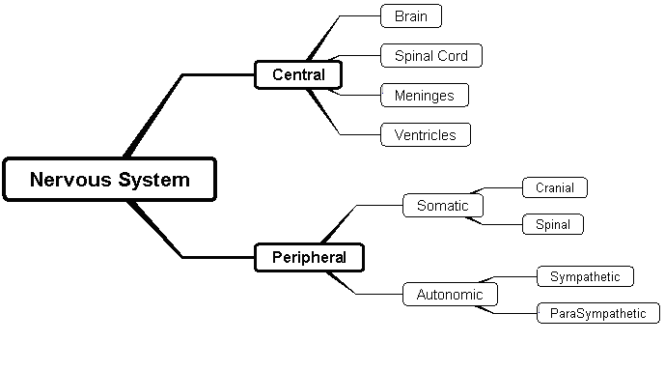

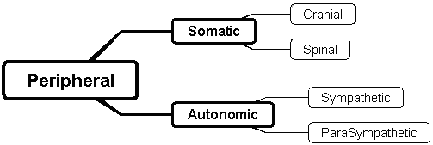

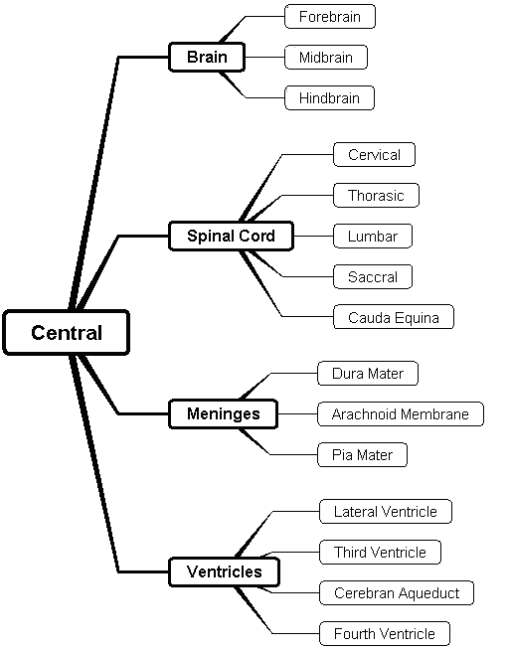

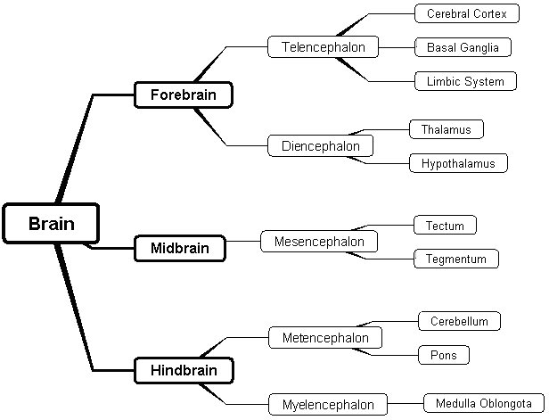

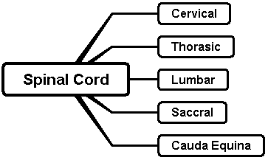

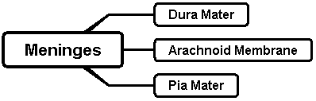

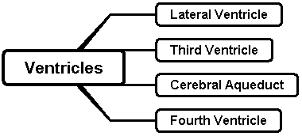

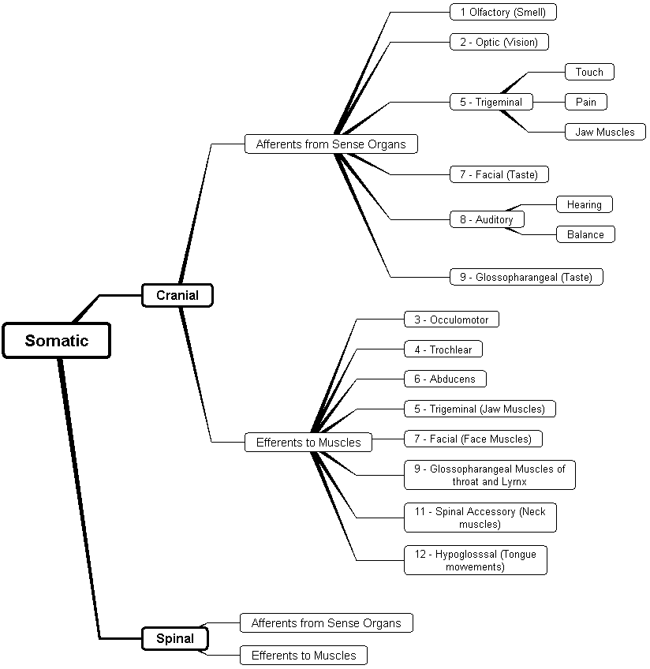

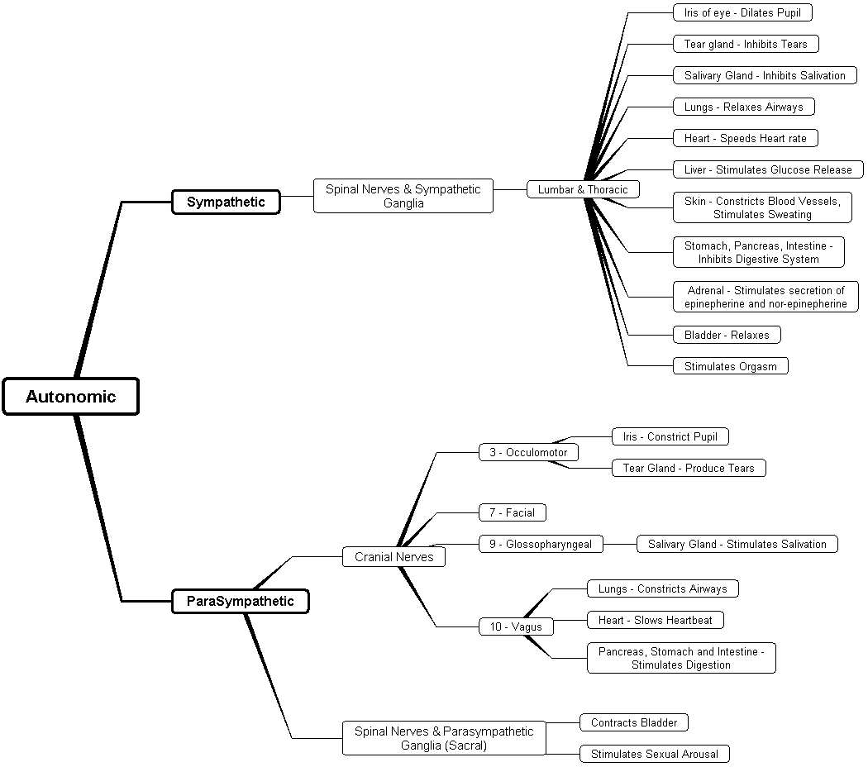

► [Return to Lecture Guide: Basic Features of the Nervous System](#LG_I_BasicFeatures), [Development of the Nervous System](#LG_IIR_DevelopmentNervousSystem), [The Central Nervous System](#LG_II_CentralNervousSystem), [The Peripheral Nervous System](#LG_III_PeripheralNervousSystem)

▼ [Return to List of Handouts for Chapter 3](#Handouts_OPN)

▲ [Return to Chapter 3: Table of Contents](#CHOPN_TOC)

Handout 3.2: Vocabulary crossword puzzle

Name: \_\_\_\_\_\_\_\_\_\_\_\_\_\_\_\_\_\_\_\_\_\_\_\_\_\_\_\_\_\_\_\_\_\_\_\_\_\_\_\_ Section: \_\_\_\_\_\_\_\_\_\_\_\_\_\_ Date: \_\_\_\_\_\_\_\_\_\_\_\_

The Nervous System

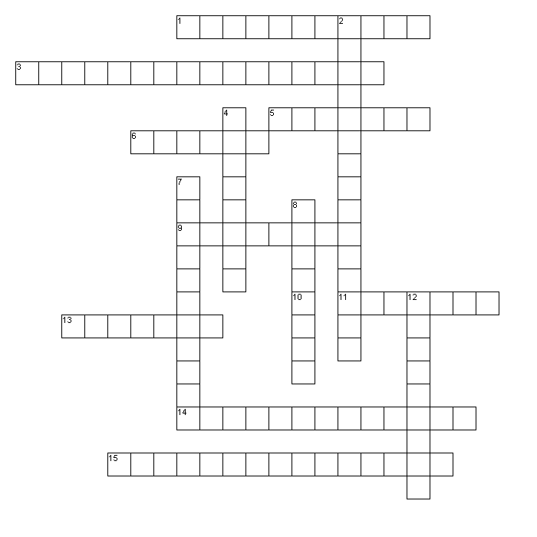

Across

1. Rope-like structure carrying information from the brain to the body

3. Name means “black stuff”

5. You would have trouble breathing after damage to this area

6. Outer layers of brain or adrenal glands

9. Lobe of cortex behind the central sulcus

10. “System” involved in emotions

11. Part of the nervous system responsible for sensory and motor functions

13. Area of cortex responsible for decision making

14. Area of cortex in the parietal lobe responsible for information from skin, muscles, and tendons

15. Digestion is controlled by this part of the peripheral nervous system

Down

2. Contains fibers that connect the two halves of the cerebellum

4. Name of this area of cortex may remind you of a religious building

7. Involved in memory and part of the limbic system

8. Striped part of the basal ganglia

12. Part of peripheral nervous system that reacts “automatically”

Puzzle created with Puzzlemaker at DiscoverySchool.com

► [Return to Lecture Guide: The Central Nervous System](#LG_II_CentralNervousSystem), [The Peripheral Nervous System](#LG_III_PeripheralNervousSystem)

▼ [Return to List of Handouts for Chapter 3](#Handouts_OPN)

▲ [Return to Chapter 3: Table of Contents](#CHOPN_TOC)

Handout 3.3

A Handy Model of the Human Brain

Sometimes it is difficult to remember the major structures of the human brain and to understand their three-dimensional relationship. Here are some ideas that might be helpful to you in your studies.

Mnemonic Devices

Mnemonic devices have traditionally been the most effective tool for a student trying to put unfamiliar information into memory. Mnemonic devices build associations between the familiar and the new. These 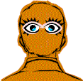associations can then be used to cue memory.

Did your father always know when you were up to some type of mischief? Did he appear to have “eyes in the back of his head”?

In one way, he did. The cortical area responsible for vision is at the back of the brain.

In Ancient Greece, the priestesses, called Oracles, would hear voices giving them important information about people and events. Most of the Oracles lived (or worked) in a temple. Under your temples (at the side of your head, under the temple of your glasses) is the temporal lobe. This part of the brain has cortex responsible for audition (or hearing).

Here is another mnemonic device to assist you in remembering the location of brain structures.

A Brain Model

The two hemispheres

First, imagine that each of your hands represents one of the two hemispheres of your brain. Fold your hands into fists and hold your hands in front of you with the thumbs on the outside. The place where your hands touch represents the corpus callosum, where the two halves of the brain are 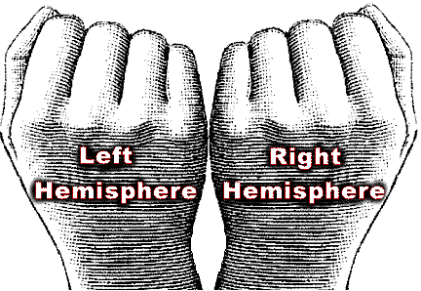connected.

The right hand represents the left hemisphere and the left hand represents the right hemisphere.

This will help you to remember that the opposite side of the brain controls the movement and sensation from the body. The neurons cross at a level in the brain stem represented by your wrists.

This is called the decussation (or crossing) of the pyramids.

Why did you curl your hands into a fist?

Some of the structures inside the skull of a human being are 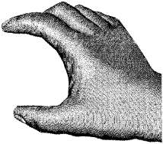curved in a “C” shape. This probably evolved through preference for infants with smaller skulls who still had the same density of neurons to support future learning. (Ask any mother if a small skull at birth is a good idea.) The more surface area a brain has on the cortex, or skin of the brain, the 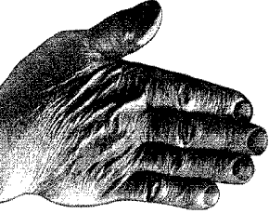more neurons it can support. The c-shape of the cortex makes more surface area. So does the wrinkled surface of the brain.

The cortex has many wrinkles. The high part of each wrinkle is called a gyrus. The valley between two wrinkles is called a sulcus. If the valley is deep and long and divides major areas of the cortex, it may be called a fissure.

Different areas on the skin of your hand can represent the different lobes of the cortex.

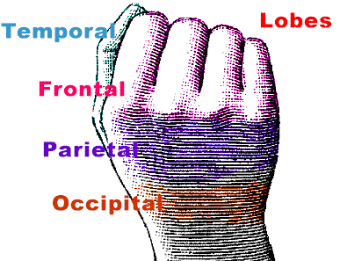The fingers represent the frontal. This part of the cortex is involved in complex thought and problem solving, as well as emotional control.

The area at base of the fingers that is still within the frontal lobe represents that motor cortex. This area is responsible for voluntary movement below the neck.

The thumb represents the temporal lobe. Like the thumb, this area can be lifted away from the rest of the hand/brain, though it remains attached at the base, part of the C shaped curve of the structures. This area has cells responsible for hearing and taste.

At the back of the hand is an area that represents the occipital lobe. The occipital lobe is responsible for basic vision.

The area remaining, the parietal lobe, appears to have cells responsible for complex relationships between other areas.

Underneath the occipital lobe at the back of the brain, is the cerebellum, or little brain. (The large, main-brain is referred to as the cerebrum.) You might imagine it as a bracelet around your wrist. The top of the bracelet is very detailed. The band going around your wrist can represent the fibers of the neurons in the cerebellum connecting the two hemispheres of the cerebellum at the front of the brain stem in two lumps called the pons.

► [Return to Lecture Guide: The Central Nervous System](#LG_II_CentralNervousSystem)

▼ [Return to List of Handouts for Chapter 3](#Handouts_OPN)

▲ [Return to Chapter 3: Table of Contents](#CHOPN_TOC)

Handout 3.4: Diagrams of the Nervous System

Name: \_\_\_\_\_\_\_\_\_\_\_\_\_\_\_\_\_\_\_\_\_\_\_\_\_\_\_\_\_\_\_\_Section: \_\_\_\_\_\_\_\_\_\_\_\_\_\_\_\_\_ Date: \_\_\_\_\_\_\_\_\_\_\_\_\_\_\_\_\_

An important part of understanding the nervous system is to be able to look at a diagram, x-ray, or model and find a structure. This is made more complicated by the lack of differences in the look of nervous system tissue with different functions.

Even looking at diagrams can be confusing because they are from different points of view and may not look like the diagrams in the text, models you have used in class, or even dissections of real brains.

I will give you a series of diagrams of the nervous system to label. Some will be very detailed and some are rough sketches. You will need to look at the diagram carefully and determine if there are structures that you recognize. From these you can find and label other structures.

bd05199_

\_\_ \_\_ \_\_ \_\_ \_\_ \_\_ View

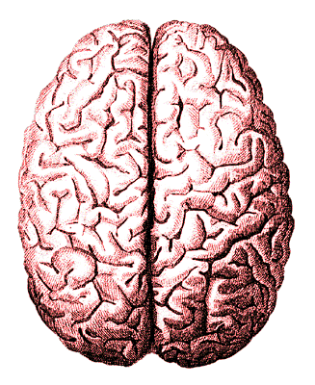

\_\_ \_\_ \_\_ \_\_ \_\_ \_\_ View

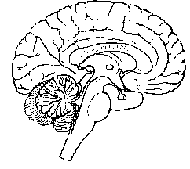

\_\_ \_\_ \_\_ \_\_ \_\_ \_\_ View

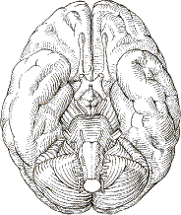

\_\_ \_\_ \_\_ \_\_ \_\_ \_\_ \_\_ View

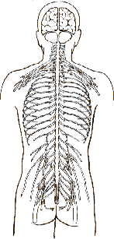

\_\_ \_\_ \_\_ \_\_ \_\_ \_\_ \_\_ \_\_ \_\_ \_\_ Nervous System

► [Return to Lecture Guide: The Central Nervous System](#LG_II_CentralNervousSystem)

▼ [Return to List of Handouts for Chapter 3](#Handouts_OPN)

▲ [Return to Chapter 3: Table of Contents](#CHOPN_TOC)

Handout 3.5: Structure of the Nervous System

Name: \_\_\_\_\_\_\_\_\_\_\_\_\_\_\_\_\_\_\_\_\_\_\_\_\_\_\_\_\_\_\_\_Section: \_\_\_\_\_\_\_\_\_\_\_\_\_\_\_\_\_ Date: \_\_\_\_\_\_\_\_\_\_\_\_\_\_\_\_\_

**Brain**

**Forebrain**

**Lobe**

**Hypo-thalamus**

**Tegmentum**

**Lumbar**

**Gustation**

► [Return to Lecture Guide: The Central Nervous System](#LG_II_CentralNervousSystem), [The Peripheral Nervous System](#LG_III_PeripheralNervousSystem)

▼ [Return to List of Handouts for Chapter 3](#Handouts_OPN)

▲ [Return to Chapter 3: Table of Contents](#CHOPN_TOC)

Handout 3.6: Learning Medical Terms

|  |  |
| --- | --- |
| Human Brain | Capit—head  Cephalo—head  Cerebello—cerebellum (part of brain) “small brain”  Cerebro—cerebrum (part of brain)  Cranio—head  Encephalo—brain  Neuro—nerve |
| Human Heart | Cardi- or cardio—heart |
| Mouth and tongue | Glosso—tongue  Laryngo—larynx  Linguo—tongue  Stoma—mouth  Os–bone—or mouth |
| Skeleton | Arthro—joint  Carpo—wrist  Genu— knee (Latin)  Osteo—bone |
| Human Noserhino | Naso—nose  Rhino—nose |
| Orchid | Orchio, orchido—testis  Ovario—ovary |
| Diagram of Skin and Hair | Meningo—meninges (coverings of the brain and spinal cord)  Derma—skin  Pilo—hair  Cilia—hair (Latin)  Fibro—fibers |
| Human Foot | Ped—foot |
| Human Liver and Organs | Adeno—gland  Adreno—adrenal gland |
| Human Spinal Cord | Myelo—bone marrow and spinal cord  (Note: The use of this term will determine which tissue is meant.)  Myo—muscle (Note: The Latin word for muscle is mus.)  Chordo or Cordo—cord or string |
| Human Ear | Oto—ear |
| Human Eye | Oculo—eye |
| Hippopotomous | Hippo—Horse Hippocampus (seahorse shaped) |

► [Return to Lecture Guide: Basic Features of the Nervous System](#LG_I_BasicFeatures), [The Central Nervous System](#LG_II_CentralNervousSystem)

▼ [Return to List of Handouts for Chapter 3](#Handouts_OPN)

▲ [Return to Chapter 3: Table of Contents](#CHOPN_TOC)

Handout 3.7: Learning Medical Terms: Basic Greek and Latin

| Root | Meaning | Examples |
| --- | --- | --- |
| **A (an before vowel)** | Without, lack of | Apathy (lack of feeling); apnea (without breath); aphasia (without speech) |
| **Ab** | Away from | Abductor (leading away from) |
| **Ad** | To, toward, near to | Adhesion (sticking to); adrenal (near the kidney) |
| **Algia** | Pain | Neuralgia (nerve) |
| **Ambi** | Both | Ambidextrous (ability to use hands equally); ambilaterally (both sides) |
| **Audi, audio** | Hear, hearing | Audiometer (measure) |
| **Bi** | Twice, double | Bifocal (two foci); bifurcation (two branches) |
| **Brachy** | Short | Brachycephalia (head); brachydactylia (fingers) |
| **Brady** | Slow | Bradypnea (breath); bradycardia (slowed heart rate) |
| **Brevis** | Short | Brevity; breviflexor (short flexor muscle) |
| **Cau, caus** | Burn | Caustic (suffix added to make adjective); cauterization; causalgia (burning pain) |
| **Com/Con** | With, together | Commissure (sending or coming together); conductor (leading together); concentric (having a common center) |
| **Contra** | Against, opposite | Contralateral (opposite side); contraception (prevention of conception); contraindicated (not indicated) |
| **De** | Away from | Dehydrate (remove water from); decompensation (failure of compensation) |
| **Dextro** | Right | Ambidextrous (using both bands with equal ease); dextrophobia (fear of objects on right side) |
| **Di** | Twice, double | Diplopia (double vision); dichromatic (two colors) |
| **Dys** | Difficult, disordered, painful | Dysarthria (speech); dyskinesia (motion); dysphasia (speech) |
| **Ecto** | On outer side | Ectoderm (outer skin) |
| **Em, en** | In | Encephalon (in the head) |
| **Epi** | Upon, on | Epidural (upon dura); epidermis (on skin) |
| **Eu** | Well, good | Euphoria (well-being) |
| **Extra** | Outside | Extracellular (outside cell) |
| **Fiss** | Split | Fissure; fission (suffixes added to make nouns) |
| **Flex, flec** | Bend | Flexion (suffix added to make noun) |
| **Geno, genesis** | Produce, origin | Genotype; homogenesis (same origin); pathogenesis (disease origin of disease) |
| **Glyco** | Sugar, sweet | Glycohemia (sugar in blood); glycopenia (poverty of sugar—low blood sugar level) |
| **Haplo** | Single, simple | Haploid (having a single set of chromosomes) |
| **Hemi** | Half | Hemiplegia (partial paralysis); hemianesthesia (loss of feeling on one side of body) |
| **Homo** | Same | Homogeneous (same kind or quality throughout); homozygous (possessing identical pair of genes); homologous (corresponding in structure) |
| **Hydro** | Wet, water | Hydrophobia (fear of water) |
| **Hyper** | Over, above, excessive | Hypertrophy (over-growth); hyperplasia (excessive formation) |

|  |  |  |
| --- | --- | --- |
| Root | Meaning | Examples |
| **Hypo** | Under, below, deficient | Hypothyroidism (deficiency or under function of thyroid) |
| **Im, in** | Not | Immature (not mature); involuntary (not voluntary); inability (not able) |
| **Intra** | Within | Intracerebral (within cerebrum); intraocular (within eyes) |
| **Iso** | Equal | Isochromatic (having same color throughout) |
| **Kine, kino, kineto, kinesio** | Move | Kinetogenic (producing movement); kinetic (suffix added to make adjective); kinesiology (study) |
| **Levo** | Left | Levorotation (turning to left) |
| **Macro** | Large, abnormal size | Macrocephalic (head) |
| **Malus** | Bad | Malady; malaise; malignant; malformation |
| **Medius** | Middle | Median; medium; gluteus medius (femur muscle) |
| **Megalo** | Huge | Megalomania (delusion of grandeur) |
| **Meso** | Middle, mid | Mesocarpal (wrist); mesoderm (skin) |
| **Minimus** | Smallest | Gluteus minimus (smallest muscle of hip) |
| **Mono** | One, single, limited to one part | Monochromatic (color); monobrachia (arm) |
| **Morph, morpho** | Form | Morphology; amorphous (no definite form); polymorphic (many) |
| **Neo** | New | Neoformation; neomorphism (form); neonatal (first four weeks of life); neopathy (disease) |
| **Olfact** | Smell | Olfactophobia (fear); olfactory (suffix added to make adjective) |
| **Oligo** | Few, scanty, little | Oligophrenia (mind); oligopnea (breath) |
| **Op, opto** | See | Amblyopia (dull—dimness of vision); presbyopia (old— impairment of vision in old age); optic; myopia (myein, meaning shut—nearsighted) |
| **Para** | Beside, near to | Parathyroid (near the thyroid) |
| **Phas** | Speak, utter | Aphasia (unable to speak); dysphasia (difficulty in speaking) |
| **Phil** | Like, love | Hemophilia (blood—a hereditary disease characterized by delayed clotting of blood); acidophilia (acid stain—liking or staining with acid stains); philanthropy (love of mankind) |
| **Phobia** | Fear | Hydrophobia (fear of water); photophobia (fear of light); claustrophobia (fear of close places) |
| **Plegia** | Paralyze | Paraplegia (paralysis of lower limbs); hemiplegia (partial paralysis) |
| **Poly** | Many, much | Polymyalgia (pain in many muscles) |
| **Pseudo** | False, spurious | Pseudostratified (layered) |
| **Re** | Back, again, contrary | Reflex (bend back); revert (turn again to); regurgitation (backward flowing, contrary to normal) |
| **Retro** | Backward, located behind | Retrograde (going backward); retrolingual (behind tongue) |
| **Schiz** | Split, divide | Schizophrenia (mind split personality) |
| **Sclero** | Hard | Sclerosis (hardening); arteriosclerosis (artery) |

| Root | Meaning | Examples |
| --- | --- | --- |
| **Sinistro** | Left | Sinistrocardia; sinistromanual (left-handed) |
| **Stasis** | Stop, stand still | Hematostatic (pertaining to stagnation of blood) |
| **Teg, tect** | Cover | Tegmen; tectum (roof like structure); integument (skin covering) |
| **Thermo** | Heat, warm | Thermal; thermometer |
| **Trans** | Across, beyond | Transection (cut across); transmit (send beyond) |
| **Ultra** | Beyond, in excess | Ultraviolet (beyond violet end of spectrum); ultrasonic (sound waves beyond the upper frequency of hearing by human ear) |

► [Return to Lecture Guide: Basic Features of the Nervous System](#LG_I_BasicFeatures), [The Central Nervous System](#LG_II_CentralNervousSystem)

▼ [Return to List of Handouts for Chapter 3](#Handouts_OPN)

▲ [Return to Chapter 3: Table of Contents](#CHOPN_TOC)

PowerPoint Presentations

Enhanced Lecture PowerPoint Slides with Embedded Videos (ISBNs for Lecture PPTs 0134319265; Video PPTs 0134474805; Art PPTs 0134474813). The enhanced lecture PowerPoints offer detailed outlines of key points for each chapter supported by selected visuals from the textbook, and include the videos featured in the text. Standard Lecture PowerPoints without embedded videos are also available. A separate Art and Figure version of these presentations contains all art from the textbook for which Pearson has been granted electronic permissions. Available for download on the Instructor’s Resource Center at <http://www.pearsonhighered/irc>.

▲ [Return to Chapter 3: Table of Contents](#CHOPN_TOC)

**ACCESS****ING RESOURCES FOR *PHYSIOLOGY OF BEHAVIOR*, TWELFTH EDITION**

For access to instructor supplements for *Physiology of Behavior, Twelfth Edition*, simply go to <http://www.pearsonhighered/irc> and follow the directions to register (or log in if you already have a Pearson user name and password).

Once you have registered and your status as an instructor is verified, you will be e-mailed a login name and password. Use your login name and password to access the catalog. Click on the “online catalog” link, click on “psychology” followed by “introductory psychology” and then the Carlson *Physiology of Behavior, Twelfth Edition* text. Under the description of each supplement is a link that allows you to download and save the supplement to your desktop.

For technical support for any of your Pearson products, you and your students can contact [http://247.pearsoned.com](http://247.pearsoned.com/).

▲ [Return to Chapter 3: Table of Contents](#CHOPN_TOC)